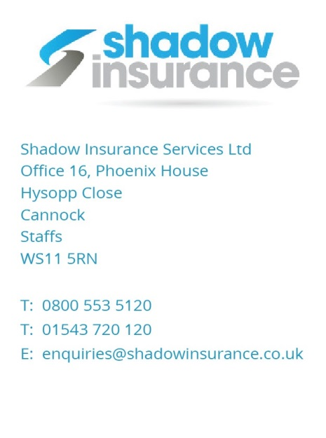

Newport Paper Company Limited
Unit 3
Springfield Industrial Estate
Newport, Shropshire
TF10 7NB
Our ref. 9820834
31st July 2018
TO WHOM IT MAY CONCERN

Re: | CONFIRMATION OF COVER – NEWPORT PAPER COMPANY LTD – UNIT 3 SPRINGFIELD INDUSTRIAL ESTATE NEWPORT SHROPSHIRE TF10 7NB

I refer to the above and would confirm that Newport Paper Company Ltd currently have an Office Contents Combined Insurance Policy with Aviva under policy number: 96OSP1006175 which is fully paid to date up to 10 August 2019.

The Aviva policy provides cover for Employers Liability Insurance with a limit of indemnity of £10 Million and a Public Liability limit of indemnity of £5 Million.

We also arrange an Excess Public Liability Insurance Cover with APC under policy number UY57UY55 which provides an additional £5 Million limit of indemnity cover over and above the Aviva policy.

The APC policy runs from 31.3.2018 to 30.3.2019

Should you require any further information or assistance please do not hesitate to contact us.

Yours faithfully,

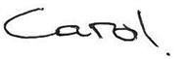
Carol McEwan
Commercial Account Handler
Dial Direct: 01952 822295
E: cmcewan@henshalls.com

On behalf of Mr Martin Pitchford, Director E: mpitchford@henshalls.com

